Разработка урока «Какая погода в вашем регионе?»

Прохорова Регина Васильевна, учитель английского языка
МАОУ «Гамовская средняя школа»

A speaking lesson
Topic: Speaking lesson: “What is the weather like in your region?”
Level: Primary classes
Learning Outcome:
By the end of the lesson learners will: learn new word and use them in a short dialogue, ask questions about the weather using the construction “What is the weather like…?”, “It is …. degrees Celsius”, learn the difference between two values of temperatures : Celsius and Fahrenheit degrees.
How will learners work: individually, in pairs
How will learners be assessed and given feedback: self-evaluation, marks
Resources: Student’s book Starlight, worksheets (students’ cards for speaking practice)

Stage | Stage aims | Procedure |  | Interaction patterns | Timing
 |  | Teacher | Students
Setting up a speaking activity
Lead-in | to introduce the topic | Look at the board, pay attention to the cloud of words on the board. What are all these words associated with? Temperature, degrees Celsius, degrees, Fahrenheit degrees, hot, cold, sunny  - Write down your 3 associations on the sheets of paper.  - Exchange your sheet of paper with your partner.  - Tick the words which you haven’t mentioned and complete your list with them.  How many common words have you mentioned? Can you guess the topic of the lesson by these words?  Absolutely right. Today we will speak about the weather in different cities and in your region as well. | Guessing the topic by the word cloud of words, sharing ideas with a partner, revising adjectives describing weather.  The topic of the lesson is “Weather”, “Temperatures in different region” | Student-student  Student-teacher | 5 min
Giving the task | to create a communicative situation, to give a purpose for speaking and listening, to explain how to do the task | Look at the Ex 1. There is a short dialogue. Let’s read it:  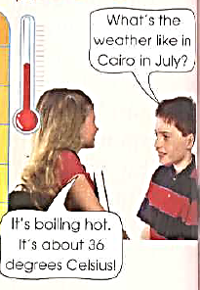  What question does the boy ask to know the weather in Cairo?  How does the girl describes the weather? What adjectives does the girl use to answer the question?  The girl uses “Degrees of Celsius” to say about the temperature. Do you know any other values of the temperatures?  Look at the picture to the ex.1. There to ways temperatures values: Celsius and Fahrenheit degrees.  0 degrees Fahrenheit is equal to -17.77778 degrees Celsius:  0 °F = -17.77778 °C | Ss are reading the dialogue in pairs.  The boy asks the following question: “What is the weather like in …?”  “It is about…. degrees”, “boiling hot”  No. we don’t know any other values of the temperatures. | Student-student  Teacher -student | 8 min
Demonstration,  practising the language | to demonstrate how to do the task  to practise the language | Let’s look at the table of the ex.1  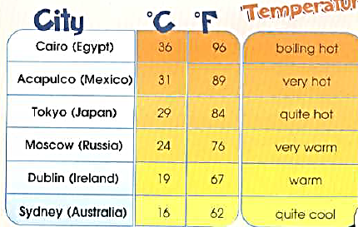  Take one of the cards on the table. Read the task. Ask and answer questions as in the example:  Card 1.  Ask your partner about the weather in Acapulko (Celsius) and Sydney (Fahrenheit). Answer the partner’s questions.  Use the structure “What is the weather like in ____?” to ask a question and adjectives given in the table to answer the partner’s questions.  Card 2.  Ask your partner about the weather in Tokyo (Celsius), Dublin (Fahrenheit). Answer the partner’s questions.  Use the structure “What is the weather like in ____?” to ask a question and adjectives given in the table to answer the partner’s questions. | Students are practicing the dialogue with their partner. | Teacher-student  Student-student | 8 min
Scaffolding | to help students prepare for the task (to help with ideas, structure, strategies) | Teacher monitors students, takes notes of mistakes to correct, focuses on grammar and pronunciation. | Student are practicing speaking task | Student-student
Speaking practice
Speaking practice | to let student achieve the communicative aim | Great job. You’ve learnt what is the weather like in Tokyo Dublin, Acapulko and Sydney. But what about your home region? What is the weather like in Perm in summer and in winter for example? Can you get such information?  Of course, you can. Ask your partner about the weather in your region in different seasons of the year. Reproduce your dialogues. | By the example of the ex 1 students ask and answer questions about the weather in their region in winter, spring, summer and autumn.  - What is the weather like in Perm in summer?  - It is warm. It is about 23-25 degrees Celsius.  Students one by one demonstrate their dialogues to the class. | Student-student | 10 min
Feedback
Getting feedback | to get feedback from students, to let students report back | Students, can you ask someone about the weather in different parts of the world? | Students give feedback about what have they known during the lesson.  Yes, we can. We can ask about the weather in different countries and in different seasons of the year. | Teacher- student | 2 min
Giving feedback | to give feedback on content and language | What kind of question can you use get this information?  What degrees temperatures do you know? | What is the weather like in ….in …?  Celsius and Fahrenheit | Teacher- student | 2 min

Worksheets (Students’ cards)
Card 1.
Ask your partner about the weather in Acapulko and Sydney. Answer the partner’s questions.
Use the structure “What is the weather like in ____?” to ask a question and adjectives given in the table to answer the partner’s questions.
Card 2.
Ask your partner about the weather in Tokyo, Dublin. Answer the partner’s questions.
Use the structure “What is the weather like in ____?” to ask a question and adjectives given in the table to answer the partner’s questions.

